**Northside Hall Construction Report**

**November 9, 2017**

Prepared by:

Michael R. Scheessele

**Overview.**

Everyone expects campus building construction projects to be noisy, dirty, and inconvenient. However, the Northside Hall roof and windows construction project of summer/fall 2017 has been an unexpected example of unprofessionalism, bad management, and lack of common sense.

The sections that follow contain examples of safety, respect for property, confidentiality/privacy, access, and communication problems that have occurred in summer/fall 2017.

Why did this happen? What steps will be taken to prevent this from happening with future construction projects?

**Safety and property issues.**

Several issues jeopardized or appeared to jeopardize the safety of students, staff, faculty, and visitors to Northside Hall. The problems were particularly severe on the third floor, which houses the Computer and Information Sciences department, the Physics, Astronomy, and Geology department, and the Mathematics department. Metal shards that could cause foot injuries were left on the floor. There were potential trip hazards. Imagine making your way out of a smoke-filled building. Figure 1 shows an obstacle-laden entrance to a third floor stairwell on the Friday before start of Fall classes. Figure 2 shows a first floor stairwell on October 1st.

Figure 1 Figure 2

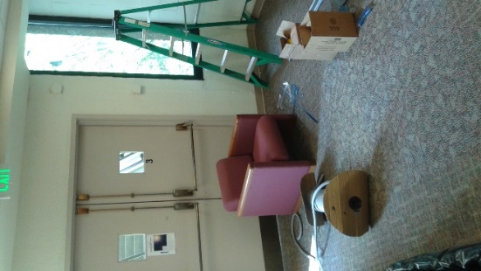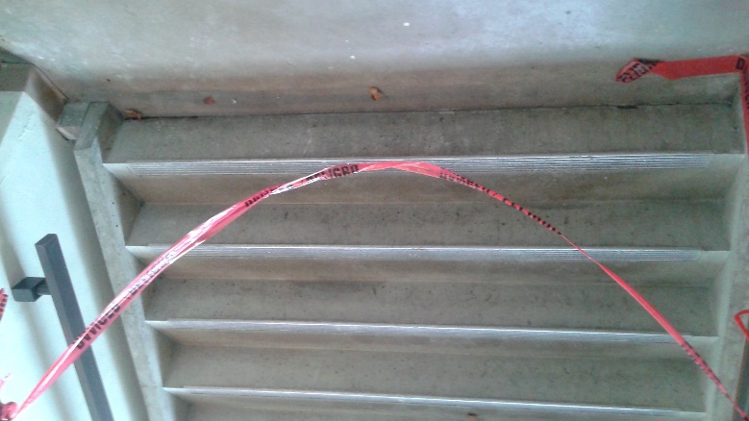

Live wires were left exposed in the Northside 340 active learning classroom. A computer science faculty member tested the wires with his own equipment, determined that the wires were indeed live, and contacted campus security for assistance. Figure 3 shows how close students were to the exposed wires and the exposed outlet. Figure 3 shows the scene after the live wires and the outlet were fixed. Figure 4 gives an idea of what the live wires looked like prior to being capped. (Figure 4 also shows NS 340, but we have been told that these particular wires are not live.)

Figure 3 Figure 4

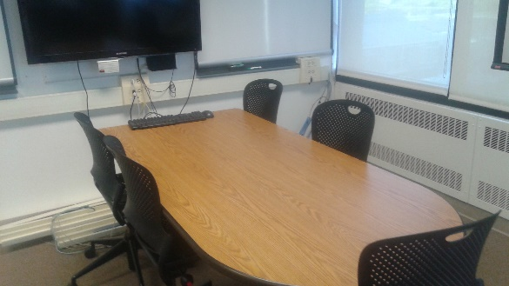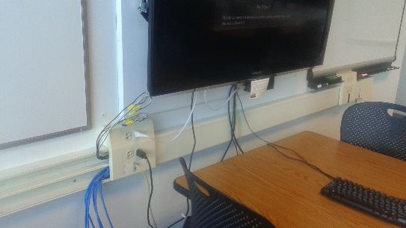



Property issues pertaining to both private and university property were also a concern. For example, the Northside 340 classroom, normally locked, was left wide open after hours. As another example, one computer science faculty member observed that construction workers had moved another computer science professor’s belongings into the hallway. This included some expensive engineering reference books. It was a Friday during the workday with workers still around. The faculty member came back Sunday evening and noticed that the other professor’s belongings were still out in the hallway unprotected. Anyone could have walked off with this personal property. He moved the books and other belongings to a secure location. As yet another example, Figures 5 and 6 show the doors of two mathematics professors left standing wide open overnight. Anyone could have walked in and stolen personal as well as university property. Perhaps most startling is Figure 7, which shows that construction workers saw fit to stack a weighty laser printer on top of an iMac computer, which in turn was stacked on top of a computer monitor. It is difficult to view this action as anything other than deliberate mischief on the one hand or profound ignorance on the other.

Figure 5 Figure 6

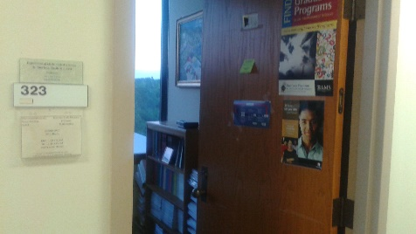 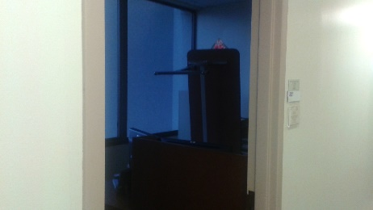

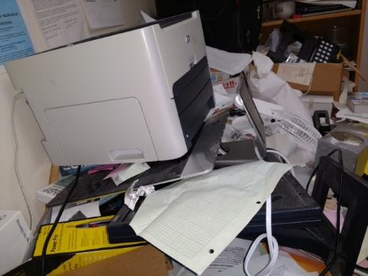 Figure 7. Laser printer on iMac.



**Confidentiality and privacy issues.**

Opened and unattended faculty/staff office doors not only jeopardize university and personal property, but also violate reasonable confidentiality and privacy expectations. On Wednesday, October 25th, the contractor left open the doors of some Computer Science and Physics faculty members (see Figures 8 and 9). Faculty members store FERPA-protected information in their offices, as well as upcoming exams and quizzes.

Figure 10 shows that some faculty offices were unsealed from other faculty offices and, in one case, unsealed from the hallway. The office depicted in Figure 10 was finally sealed at the end of the third week of classes.

Figure 8 Figure 9 Figure 10

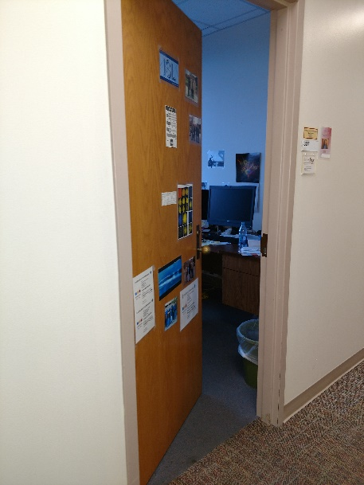 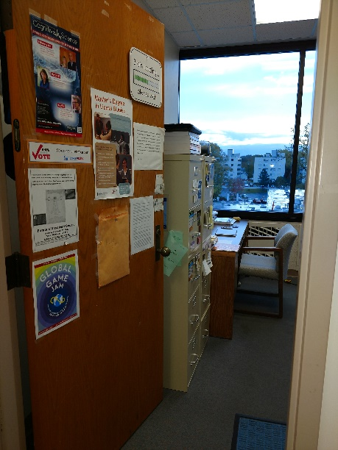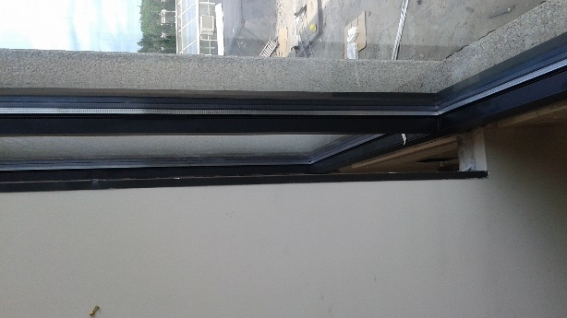

**Access issues.**

Figures 11-12 depict a third floor hallway as late as October 1st, 2017. This hallway would be difficult to navigate for someone in a wheelchair. In fact, one professor whose office is accessed from this hallway has a wheelchair-bound advisee.

Figure 11 Figure 12Figure 13

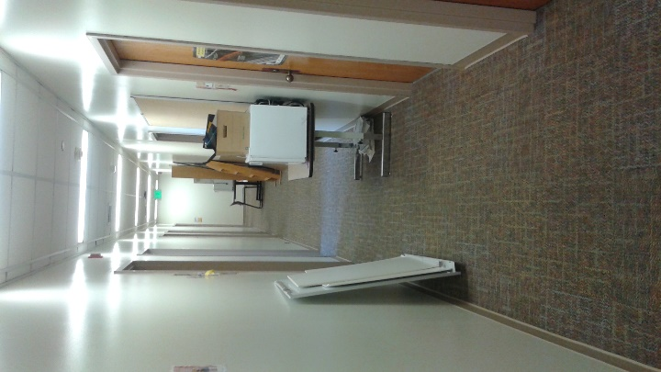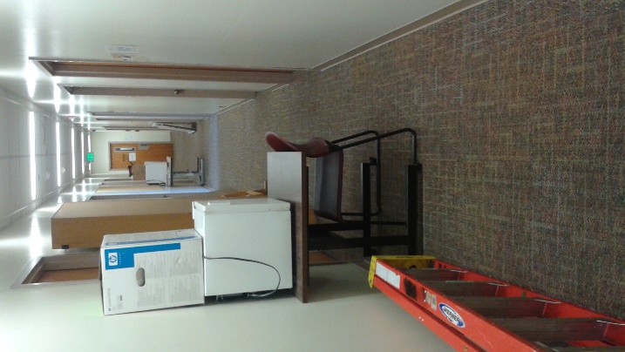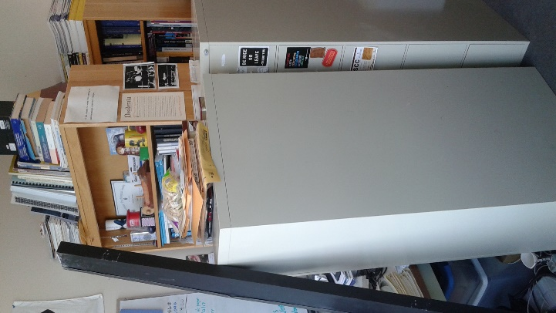

Some faculty members were deprived of full access to their offices the week before classes and after the start of classes. Multiple faculty members had to meet students in an alternative location for office hours. The office windows of another faculty member were not sealed completely such that when the wind gusted, her office sounded as if several tea kettles were coming to a boil simultaneously. This was distracting for her and for the students who came to visit her. Figure 13 (above) shows the office of a faculty member in the crucial week before classes started. Notice how the two heavy file cabinets have been positioned so that neither can be opened and both block access to the bookshelves. How can one prepare for classes like this? The vertical black bar propped against the file cabinet was the piece needed to seal the faculty member’s office from the neighboring office. Figure 13 was taken on August 18th; the faculty member’s office was finally sealed off from neighboring faculty offices on September 8th.

**Other issues.**

Shades were not installed in NS 225 and NS 340 classrooms by the start of the semester. In the case of NS 225, it was difficult for one instructor to make out the faces of students because the completely sun-exposed window was right behind the student seating. As of October 16th, the shades for some windows had not yet been installed in NS 340, making it hard for students to see the screen being projected to (see Figure 14). By the end of October, shades had not yet been installed in many faculty and staff offices (see Figure 15).

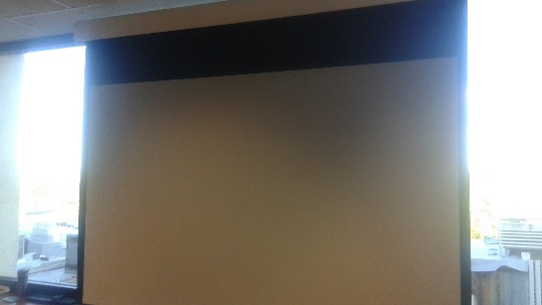Figure 14. Figure 15.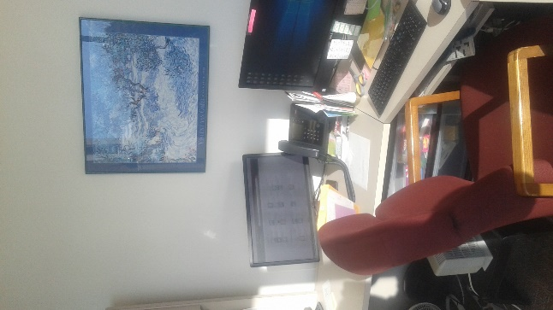

One afternoon on a Tuesday when school was in session, we were treated to a head-bangin’ concert by workmen. (If you would like the video, feel free to contact me.) The workmen were right outside the NS 204 and NS 205 classrooms. I do not know whether classes were in session at the time of the Workmen’s Ball. Several faculty were working in their offices one floor above though. Now everyone expects work-related noise during construction, but this was disrespectful to students, staff, and faculty--and just plain stupid.

**Communication issues.**

Communication about this project was poor. There was a “Daily Titan” note in June announcing the upcoming construction. There were a few general notices about closed entrances, etc., during the project. Regarding work on individual faculty offices, post-it notes were stuck on faculty office doors. For example, consider one representative case. A post-it note announced that a faculty member’s office would have work done in the third week of July. The third week of July came and went. August 1st came and went. Eventually the post-it note was changed to state that work would be done in this faculty office from August 10th-August 17th (overlapping the week before start of fall classes). The main work on the faculty office was finally completed on September 8th, with shades finally installed on November 1st. By contrast, observe the nice communication that Wiekamp inhabitants are treated to on a weekly basis during their re-wiring project:

Progress continues on the Wiekamp Rewire Project as week 9 is finished and we go into week 10   
  
Certification of the cable on the second floor south side is done and users will continue to be moved over to the new cabling this upcoming week.   
  
Cabling of the first floor north side has started and will continue this upcoming week.   
  
With the high ceilings and over 250 cables that need to be pulled, contractors will be working on the north side for about 2 weeks.  
  
UITS will continue to keep the campus and all stakeholders informed on the project as it progresses.  
  
If you have any questions or concerns, please feel free to contact Phil Mikulak at: [pmikulak@iusb.edu](https://www.exchange.iu.edu/owa/redir.aspx?REF=9m0Poic7kg3UGSFsHHwJFDWnHTeUBzUNa54TPV5zb8gYs5HoFSTVCAFtYWlsdG86cG1pa3VsYWtAaXVzYi5lZHU.)

The Facilities Management Director Michael Prater told the Facilities Management Committee at the October meeting that the Northside project has 6 sub-contractors, while the Wiekamp project has one. Fair enough. But uninformative and wildly inaccurate post-it notes? Mr. Prater indicated agreement that communication could be improved.

**Epilogue.**

At the October meeting of the Facilities Management Committee, Mr. Prater reported that administrators down state choose the contractor on construction projects. He told us that there are no penalties to the contractor for problems and no mechanisms to keep the contractor on schedule. We asked him why faculty were not relocated temporarily during construction. He said that the contractor told them that construction on a faculty office would only take 2-3 days. (From start to finish, 2-3 months is a more accurate depiction of the actual timeframe.) Mr. Prater agreed that the contractor “failed to execute.” He seemed to welcome input from the committee and expressed a desire to get our “information out in front of the next phase” of construction and to work with Bloomington to improve this process. In the meantime, he encouraged us to let Northside faculty/staff know that they could call him regarding damages and outstanding issues. I contacted Mr. Prater several times after the October meeting with outstanding issues and found him to be responsive. I observed the Assistant Director James Mason proactively monitoring and inspecting Northside Hall for problems on at least two occasions. Mr Mason also reportedly chewed out the contractor for leaving the Computer Science and Physics faculty doors open on Wednesday, October 25th.

The hope of the Facilities Management Committee is that this report will assist IU South Bend administrators in pressuring IU Bloomington administrators to do a better job in selecting contractors and guaranteeing that they execute future construction projects in a safe, respectful, and timely manner. If any administrator is skeptical, consider it from this angle. If you were a student with classes mostly in Northside Hall, would you return for a second year? If you were the parent of a student and observed as the shenanigans of the summer/fall 2017 construction project unfolded, would you send your child back for another year? What if someone had been injured on this project? Given some of the irresponsible things we witnessed, this scenario is not implausible.