How to transfer your active learning activities from classroom to classroom

An Active Learning Activity Planner, Worksheet One

Every Indiana University classroom features a variety of digital and analogue tools, (such as tables and chairs, screens, whiteboards, etc.) that influence what activities and interactions instructors can plan for student engagement. The worksheets below are designed to support IU instructors in identifying what classroom tools they might use to support approaches to a variety of active learning. The second worksheet helps instructors reflect on how they might amend interactions and activities when they move into a new classroom with a different set of tools.

Classroom #1
Image of Lecture Hall 104, IUPUI Campus  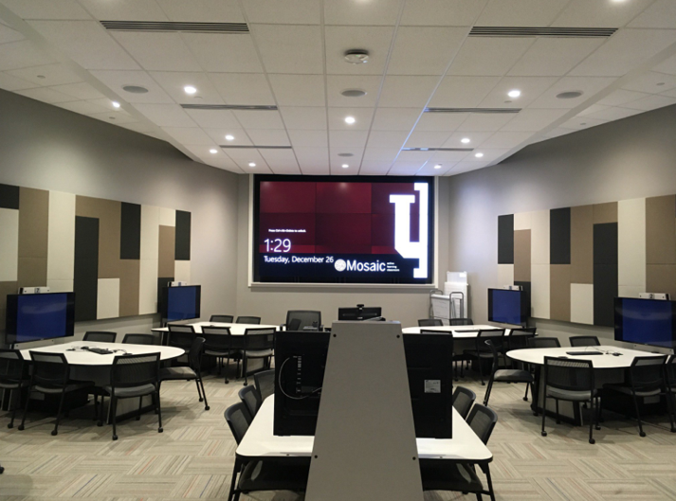 | Classroom Features  - 3 x 3 Video wall  - 9 student tables with shared displays  - 9 Student Collaboration Displays  - Student Dry Erase Boards  - Document Camera (non-USB)  - Specialty Lecture Capture

These documents were created by Dr. Tracey Birdwell, Program Director of the Mosaic Initiative at Indiana University. How to transfer your active learning activities from classroom to classroom is licensed under a Creative Commons Attribution-NonCommercial-ShareAlike 4.0 International License.

Worksheet One: Classroom #1
Use this worksheet to help identify which classroom features best support your planned activity.

Briefly describe your planned activity:

What is your learning objective?

Interaction Plan: With whom and with what content will students interact as part of the activity?

Tools: What tools (physical or virtual) will you use to support they activity? How will you use them?

Learning Artifact: What will your students produce during this activity? How will they collaborate/share their work?

Troubleshooting: What are some logistical/technical issues that you could anticipate that might interfere with your plan? How do you address them?

_________________________________________________________________________________________________
This document is informed by:
- Brooks, D. C. (2011). Space matters: The impact of formal learning environments on student learning. British Journal of Educational Technology, 42(5), 719-726.
- Birdwell, T., Utamchandani, S. (2019). Learning to Teach in Space: Design Principles for Faculty Development in Active Learning Classroom. Journal of Learning Spaces, 1(8), 19-27.

Classroom #2
Image of AD 1000, IUPUI Campus  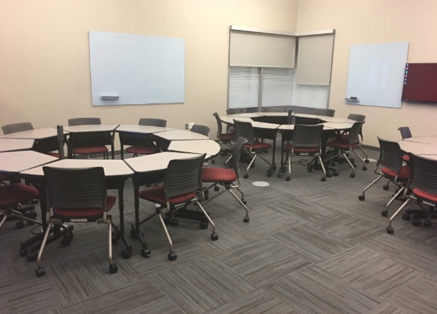 | Classroom Features  - Seats 24 Students  - Configurable tables and chairs  - Large touchscreen video wall  - Four student glass boards  - Student Collaboration Displays  - Document Camera (non-USB)  - Wireless Presentation (Solstice)

List the biggest differences in Classroom #2 features compared to Classroom #1:
Difference 1

Difference 2

Difference 3

Worksheet Two: Classroom #2
Use this worksheet to help you think about how to amend and transfer the activity from Worksheet #1 into a different classroom.

Briefly describe your planned activity:

What is your learning objective?

Interaction Plan: With whom and with what content will students interact as part of the activity?

Tools: What tools (physical or virtual) will you use to support they activity? How will you use them?

Learning Artifact: What will your students produce during this activity? How will they collaborate/share their work?

Troubleshooting: What are some logistical/technical issues that you could anticipate that might interfere with your plan? How do you address them?

